**Java Exceptions**

The Exception Handling in Java is one of the powerful mechanism to handle the runtime errors so that the normal flow of the application can be maintained.

it's types, and the difference between checked and unchecked exceptions.

**What is Exception in Java?**

Exception is an abnormal condition.

**What is Exception Handling?**

Exception Handling is a mechanism to handle runtime errors such as ClassNotFoundException, IOException, SQLException, RemoteException, etc.

**Hierarchy of Java Exception classes**

The java.lang.Throwable class is the root class of Java Exception hierarchy inherited by two subclasses: Exception and Error.

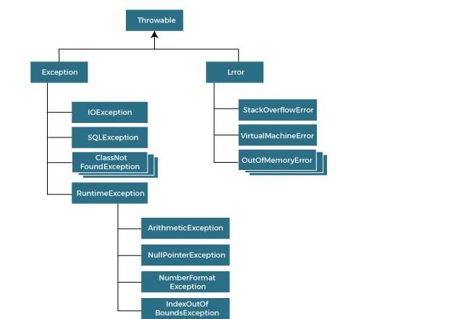

### Types of Java Exceptions

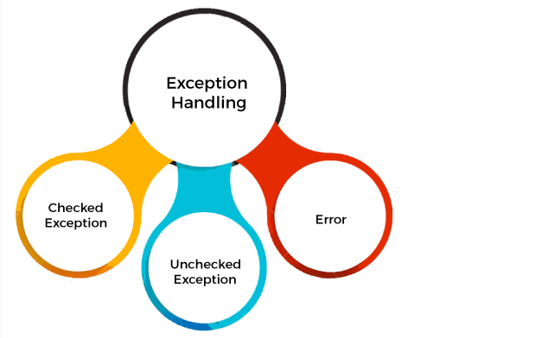

1) Checked Exception

The classes that directly inherit the Throwable class except RuntimeException and Error are known as checked exceptions. For example, IOException, SQLException, etc. Checked exceptions are checked at compile-time.

2) Unchecked Exception

The classes that inherit the RuntimeException are known as unchecked exceptions. For example, ArithmeticException, NullPointerException, ArrayIndexOutOfBoundsException, etc. Unchecked exceptions are not checked at compile-time, but they are checked at runtime.

**Java Exception Keywords**

**public static void main(String args[]){**

**try{**

**//code that may raise exception**

**int data=100/0;**

**}catch(ArithmeticException e){System.out.println(e);}**

**//rest code of the program**

**System.out.println("rest of the code...");**

**}**